SMART SYSTEM LOCATION APP
(Smart Location Finder – SaaS Platform)

Full-Stack Web Application
SaaS-Based Location Search

Developed By: NAROJU ASHWANTH
Technologies: Node.js, Express,
MySQL, JavaScript, Tailwind CSS,
Leaflet.js, JWT

[April, 2026]
TABLE OF CONTENTS

1. Introduction ..................................................................................................
2. Objectives .............................................................................................................
3. Technologies Used ......................................................................................................
4. System Architecture ....................................................................................................
5. Key Features ...........................................................................................................
5.1 User Features ......................................................................................................
5.2 Admin Features .....................................................................................................
6. Backend Implementation ..............................................................................................
6.1 Server Setup ......................................................................................................
6.2 Database Connection ............................................................................................
6.3 Authentication System ...........................................................................................
6.4 API Modules ........................................................................................................
7. Frontend Implementation ......................................................................................
7.1 Authentication UI ....................................................................................................
7.2 User Dashboard .....................................................................................................
7.3 Map Integration ...................................................................................................
7.4 Autocomplete Search ...........................................................................................
8. Admin Panel ...........................................................................................................
9. Database Design .......................................................................................................
10. Security Features ...................................................................................................
11. Advantages .......................................................................................................
12. Limitations .......................................................................................................
13. Future Enhancements ..............................................................................
14. Conclusion .......................................................................................
15. Sample Credentials ...............................................................................
16. How to Run the Project ...........................................................................
17. Output Screenshots ...............................................................................
18. References .......................................................................................

SMART SYSTEM LOCATION APP
(Smart Location Finder – SaaS Platform)

ABSTRACT

The Smart System Location App is a full-stack web-based Software-as-a-
Service (SaaS) platform designed to help users efficiently search, explore,
and visualize geographical locations including states, districts, subdistricts,
and villages.

The system integrates interactive maps using Leaflet.js, real-time autocomplete
search functionality, secure user authentication using JWT, and role-based
access control. The backend is built with Node.js and Express.js, while MySQL
serves as the database for storing hierarchical location data, user records,
search history, feedback, and upgrade requests.

The platform supports multiple membership tiers (Free, Normal, Premium, and
Ultra) and provides an admin dashboard with analytics, user management,
feedback resolution, and upgrade request handling.

This project demonstrates a scalable, secure, and production-ready solution
for location-based search and management, making it suitable for real-world
applications such as government data systems, logistics platforms, and GIS
applications.
Keywords: SaaS, Location Search, Leaflet.js, Node.js, MySQL, JWT Authentication
INTRODUCTION
The Smart System Location App is not merely a directory of places; it is a
sophisticated, web-based Software-as-a-Service (SaaS) platform engineered to
solve the growing challenge of discovering and visualizing complex geographical
hierarchies. In an era where data-driven decision-making is paramount,
governments, logistics companies, e-commerce platforms, and researchers often
struggle to efficiently navigate granular location data such as states,
districts, subdistricts, and villages. Traditional methods—relying on static
spreadsheets or basic dropdown menus—fail to provide the spatial context or
real-time interactivity required for modern applications. This project addresses
that gap by delivering a unified, intelligent interface where users can
seamlessly traverse administrative boundaries, search for specific locales
using an autocomplete engine, and instantly visualize their selections on an
interactive map.
The architecture of the platform is built on a robust three-tier model. At the
Presentation Layer, users are greeted with a responsive and dynamic interface
styled with Tailwind CSS, ensuring an intuitive experience across desktop and
tablet devices. The frontend leverages Vanilla JavaScript for logic and
Leaflet.js for map rendering, bypassing the need for expensive proprietary
mapping APIs while maintaining high performance. The Application Layer consists
of a secure Node.js and Express.js backend, which handles business logic, user
authentication, and API routing. The Data Layer is powered by a MySQL database
(villages_api), meticulously structured to maintain referential integrity across
hierarchical tables, ensuring that every village is correctly linked to its
parent subdistrict, district, and state.

One of the core problems this system solves is the inefficiency of "blind"
location selection. In many legacy systems, users must guess or know the exact
spelling of a remote village, leading to errors and frustration. The Smart
System Location App introduces a real-time autocomplete search that queries the
database as the user types, predicting location names regardless of case
sensitivity or minor spelling errors. Furthermore, the cascading dropdown
navigation (State → District → Subdistrict → Village) enforces logical data
traversal, eliminating invalid selections and reducing server load by fetching
only necessary data at each step. Once a village is selected, the platform
dynamically generates an interactive map marker, providing instant geospatial
confirmation—a feature critical for logistics planning, emergency response
coordination, or academic research.
From a business and access control perspective, the platform adopts a
membership-based SaaS model with four tiers: Free, Normal, Premium, and Ultra.
Each tier can theoretically be configured with different access limits (e.g.,
number of searches per day or export capabilities). This is managed through a
robust authentication system utilizing JWT (JSON Web Tokens) and bcrypt password
hashing. New users must register and receive admin approval, ensuring that only
vetted individuals or organizations can access the system. This makes the
platform suitable for enterprise environments where data governance is non-
negotiable. Additionally, the system tracks every search via a searches table,
not only providing users with a "recent search history" feature but also
feeding into an admin analytics dashboard. Admins can view charts of popular
search terms, manage user roles, approve membership upgrade requests, and
resolve feedback—turning the application into a complete operational tool
rather than a static directory.
OBJECTIVES
The following objectives were established for the development of the Smart
System Location App:
1. To provide a user-friendly platform for searching and exploring geographical
locations including states, districts, subdistricts, and villages.
2. To implement hierarchical location navigation allowing users to drill down
from State → District → Subdistrict → Village in a logical manner.
3. To enable real-time autocomplete search functionality that predicts location
names as the user types.
4. To integrate map visualization using Leaflet.js, displaying the exact
location of selected villages with interactive markers.
5. To implement user authentication and role-based access control using JWT
tokens and bcrypt password hashing.
6. To provide an admin dashboard with analytics, user management, feedback
resolution, and upgrade request handling capabilities.
7. To develop a scalable SaaS-based architecture supporting multiple membership
tiers (Free, Normal, Premium, Ultra).
8. To record user search history and provide recent searches functionality for
better user experience.
9. To allow users to submit feedback and request membership upgrades through
the platform.
10. To implement secure API endpoints with proper validation and authorization
middleware.

TECHNOLOGIES USED
FRONTEND
HTML5 - Structure of web pages
CSS3 - Styling and responsive design
Tailwind CSS - Utility-first CSS framework for rapid UI
JavaScript - Client-side logic and API interactions
Leaflet.js - Interactive mapping and geolocation
Font Awesome - Icons for UI elements

BACKEND
Node.js - JavaScript runtime environment
Express.js - Web framework for building REST APIs

DATABASE
MySQL - Relational database management system
(villages_api) - Database containing location hierarchies

SECURITY & AUTHENTICATION
JWT - JSON Web Tokens for secure authentication
bcrypt - Password hashing library
dotenv - Environment variable management
ADDITIONAL TOOLS
CORS - Cross-Origin Resource Sharing middleware
mysql2/promise - MySQL client with Promise support
nodemon - Development server auto-restart tool
Chart.js - Analytics charts for admin dashboard
SYSTEM ARCHITECTURE
The system follows a 3-tier architecture pattern, separating concerns into
presentation, application, and data layers.

PRESENTATION LAYER (Client)
• HTML/CSS/JavaScript (Frontend)
• User Dashboard
• Admin Dashboard
• Login/Register Pages
• Leaflet.js Map Integration
• Autocomplete Search UI

APPLICATION LAYER (Server)
• Express.js API Server
• Authentication Middleware (JWT)
• Authorization Middleware (Role-based)
• Business Logic
• API Modules:
Auth APIs (Register, Login)
Location APIs (States, Districts, Villages)
User APIs (Profile, Search, Feedback)
Admin APIs (Users, Analytics, Upgrades)

DATA LAYER (Database)
• MySQL Database (villages_api)
• Tables:
users
states
districts
subdistricts
villages
searches
feedback
upgrade_requests

DATA FLOW DIAGRAM:

User
Browser
HTTP Request
Express Routes
Middleware (Auth/JWT)
Controller Logic
Database Query
JSON Response
Browser
UI Update

KEY FEATURES
USER FEATURES
1. User Registration & Login
- Secure signup with email and password
- Password hashing using bcrypt
- JWT token generation upon login

2. Membership-Based Access
- Free Tier (Basic access)
- Normal Tier
- Premium Tier
- Ultra Tier (Full access)

3. Cascading Dropdown Navigation
- State → District → Subdistrict → Village
- Dynamic loading of child data

4. Autocomplete Village Search
- Real-time suggestions as user types
- Debounced API calls for performance

5. Interactive Map Display
- Leaflet.js integration
- OpenStreetMap tiles
- Marker placement on selected village

6. Recent Search History
- Tracks last 5-10 searches
- Quick re-select option

7. Profile Management
- View and edit profile details
- Change password option

8. Feedback Submission
- Submit comments/suggestions
- Rate the platform

9. Membership Upgrade Request
- Request upgrade to higher tier
- Admin approval required

ADMIN FEATURES
1. Admin Login
- Separate admin authentication
- Role-based access control

2. User Management
- View all registered users
- Approve/reject pending users
- Delete users
- Change user memberships
3. Feedback Management
- View all user feedback
- Mark as resolved
- Delete feedback

4. Upgrade Request Management
- View pending upgrade requests
- Approve or reject requests

5. Dashboard Statistics
- Total users count
- Total searches count
- Total feedback count
- Pending approvals count

6. Search Analytics
- Popular search terms (Chart.js)
- Search trends over time

BACKEND IMPLEMENTATION

6.1 Server Setup

The backend server is built using Node.js and Express.js. The entry point
is server.js, which initializes the Express application, configures
middleware, and starts the server on a specified port.

Key middleware used:
• cors - Enables Cross-Origin Resource Sharing
• express.json() - Parses incoming JSON requests
• express.static() - Serves static files (HTML, CSS, JS)

Server Initialization Code Structure:

const express = require('express');
const cors = require('cors');
const path = require('path');
require('dotenv').config();

const app = express();
const PORT = process.env.PORT || 5000;

// Middleware
app.use(cors());
app.use(express.json());
app.use(express.static(path.join(__dirname, 'public')));

// Start server
app.listen(PORT, () => {
console.log(`Server running on port ${PORT}`);
});

6.2 Database Connection
The project uses MySQL as the database. The mysql2/promise package is used
to create a connection pool, allowing efficient handling of multiple
concurrent database queries.

Database Configuration (.env file):
DB_HOST=localhost
DB_USER=root
DB_PASSWORD=root
DB_NAME=villages_api
JWT_SECRET=your-secret-key

Connection Pool Setup:
const mysql = require('mysql2/promise');
const pool = mysql.createPool({
host: process.env.DB_HOST,
user: process.env.DB_USER,
password: process.env.DB_PASSWORD,
database: process.env.DB_NAME,
waitForConnections: true,
connectionLimit: 10,
queueLimit: 0
});
6.3 Authentication System

The authentication system handles user registration, login, and password
management using JWT (JSON Web Tokens) and bcrypt for password hashing.

Registration Process:
1. User submits email, password, name
2. Password is hashed using bcrypt.hash() with salt rounds = 10
3. User is inserted into database with status = 'pending'
4. Admin approval required before login

Login Process:
1. User submits email and password
2. System checks if email exists and status is 'approved'
3. bcrypt.compare() validates password
4. Upon success, JWT token is generated containing:
- user id
- email
- role (user/admin)
- membership tier
5. Token returned to client for storage in localStorage

JWT Token Generation:

const jwt = require('jsonwebtoken');
const token = jwt.sign(
{ id: user.id, email: user.email, role: user.role },
process.env.JWT_SECRET,
{ expiresIn: '24h' }
);

6.4 API Modules
The backend is organized into several API modules:

Authentication APIs:
• POST /api/auth/register - Register new user
• POST /api/auth/login - Login user
• POST /api/auth/reset-password - Reset forgotten password

Location APIs:
• GET /api/states - Get all states
• GET /api/districts/:stateId - Get districts by state
• GET /api/subdistricts/:districtId - Get subdistricts by district
• GET /api/villages/:subdistrictId - Get villages by subdistrict
• GET /api/search/villages?q=term - Autocomplete search

User APIs:
• POST /api/search/record - Record user search
• GET /api/search/recent/:userId - Get recent searches
• PUT /api/profile/update - Update user profile
• POST /api/feedback/submit - Submit feedback
• POST /api/upgrade/request - Request membership upgrade

Admin APIs:
• GET /api/admin/users - Get all users
• PUT /api/admin/users/:id/approve - Approve user
• DELETE /api/admin/users/:id - Delete user
• GET /api/admin/feedback - Get all feedback
• GET /api/admin/upgrade-requests - Get upgrade requests
• PUT /api/admin/upgrade-requests/:id/approve - Approve upgrade
• GET /api/admin/stats - Get dashboard statistics
• GET /api/admin/search-trends - Get search analytics

FRONTEND IMPLEMENTATION
7.1 Authentication UI
The frontend is a single-page application (SPA) contained in index.html.
It features a clean authentication interface with toggle between Login and
Register forms.
Authentication Flow:
1. User fills login/register form
2. JavaScript sends fetch() request to backend API
3. On successful login, JWT token is stored in localStorage
4. User is redirected to dashboard
5. Token is included in all subsequent API requests via Authorization header
Token Storage & Usage:
// Store token after login
localStorage.setItem('token', token);

// Include token in API requests
fetch('/api/protected-route', {
headers: {
'Authorization': `Bearer ${localStorage.getItem('token')}`
}
});
7.2 User Dashboard

After authentication, users are presented with the main dashboard
containing:
• Navigation Bar - Shows user name, membership tier, logout button
• Location Panel - Cascading dropdowns for location selection
• Search Box - Autocomplete village search
• Map Container - Leaflet.js map display
• Recent Searches - List of user's previous searches
• Feedback Section - Form to submit feedback
• Upgrade Section - Button to request membership upgrade
The dashboard layout is fully responsive using Tailwind CSS, ensuring
proper display on desktop, tablet, and mobile devices.

7.3 Map Integration
Leaflet.js is used for interactive map visualization. OpenStreetMap
provides the tile layer at no cost.

Map Initialization:
// Initialize map centered on India
const map = L.map('map').setView([20.5937, 78.9629], 5);

// Add tile layer
L.tileLayer('https://{s}.tile.openstreetmap.org/{z}/{x}/{y}.png', {
attribution: '© OpenStreetMap contributors'
}).addTo(map);

// Add marker for selected village
function addMarker(lat, lng, name) {
L.marker([lat, lng])
.bindPopup(`<b>${name}</b>`)
.addTo(map);
}

When a user selects a village, the system fetches its latitude and
longitude from the database and places a marker on the map. The map
automatically centers on the marker location.

7.4 Autocomplete Search
The autocomplete search provides real-time suggestions as the user types
a village name.

Features:
• Debounced input (300ms delay) to reduce API calls
• Minimum 2 characters before searching
• Click-to-select from suggestion list
• Keyboard navigation (up/down arrows, enter)

Implementation:
let debounceTimer;
searchInput.addEventListener('input', (e) => {
clearTimeout(debounceTimer);
debounceTimer = setTimeout(() => {
const query = e.target.value;
if (query.length >= 2) {
fetchSuggestions(query);
}
}, 300);
});

async function fetchSuggestions(query) {
const response = await fetch(
`/api/search/villages?q=${encodeURIComponent(query)}`,
{ headers: { 'Authorization': `Bearer ${token}` } }
);
const suggestions = await response.json();
displaySuggestions(suggestions);
}
ADMIN PANEL:
The Admin Panel is a separate interface accessible only to users with role = 'admin'. It provides complete control over the platform.

ADMIN DASHBOARD FEATURES
Feature | Description
Dashboard Overview Cards | Displays Total Users, Total Searches, Pending Approvals, and Total Feedback in card format
User Management Table | View all users with name, email, membership, and status. Allows approve, delete, or change membership
Upgrade Requests Table | Lists users requesting upgrades with current and requested tiers. Includes approve/reject options
Feedback Management Table | Displays user feedback with timestamps. Allows marking as resolved or deleting
Analytics Section | Includes bar chart for popular searches and line chart for trends using Chart.js

USER MANAGEMENT TABLE
Column Name | Description
ID | Unique user identifier
Name | User's full name
Email | User's login email address
Membership | Current tier (Free, Normal, Premium, Ultra)
Status | Account status (Approved, Pending, Rejected)
Actions | Approve, Delete, and Change Membership options

UPGRADE REQUESTS TABLE
Column Name | Description
Request ID | Unique request identifier
User Name | Name of user requesting upgrade
Current Tier | Existing membership level
Requested Tier | Desired membership level (Normal, Premium, Ultra)
Request Date | Date and time of request
Actions | Approve and Reject options

FEEDBACK MANAGEMENT TABLE
Column Name | Description
ID | Unique feedback identifier
User Name | Name of user
Message | Feedback or suggestion
Status | Pending or Resolved
Submitted Date | Date and time of submission
Actions | Mark as Resolved or Delete

ADMIN DASHBOARD STATISTICS
Statistic | Description
Total Users | Total registered users
Approved Users | Users with approved status
Pending Approvals | Users waiting for approval
Total Searches | Total location searches
Total Feedback | Total feedback entries
Pending Feedback | Feedback not yet resolved
Pending Upgrades | Upgrade requests awaiting action

CHARTS & ANALYTICS
Chart Type | Description
Bar Chart | Top 10 most searched village names
Line Chart | Search trends over last 7/30 days
Pie Chart (Optional) | Distribution of membership tiers

ADMIN PANEL ACCESS
Item | Details
URL | http://localhost:5000/admin.html
Access | Available via "Admin Panel" link for admin users

TABLE: users
Column Name | Data Type | Description
id | INT (PK) | Auto-increment user ID
name | VARCHAR(100) | User's full name
email | VARCHAR(100) | Unique login email
password | VARCHAR(255) | Hashed password
role | ENUM | 'user' or 'admin'
membership | ENUM | 'free', 'normal', 'premium', 'ultra'
status | ENUM | 'pending', 'approved', 'rejected'
created_at | TIMESTAMP | Registration date

TABLE: states
Column Name | Data Type | Description
id | INT (PK) | State ID
name | VARCHAR(100) | State name

TABLE: districts
Column Name | Data Type | Description
id | INT (PK) | District ID
name | VARCHAR(100) | District name
state_id | INT (FK) | References states(id)

TABLE: subdistricts
Column Name | Data Type | Description
id | INT (PK) | Subdistrict ID
name | VARCHAR(100) | Subdistrict name
district_id | INT (FK) | References districts(id)

TABLE: villages
Column Name | Data Type | Description
id | INT (PK) | Village ID
name | VARCHAR(100) | Village name
subdistrict_id | INT (FK) | References subdistricts(id)
latitude | DECIMAL(10,8) | Geographic latitude
longitude | DECIMAL(11,8) | Geographic longitude

TABLE: searches
Column Name | Data Type | Description
id | INT (PK) | Search record ID
user_id | INT (FK) | References users(id)
village_name | VARCHAR(100) | Searched village name
searched_at | TIMESTAMP | Time of search

TABLE: feedback
Column Name | Data Type | Description
id | INT (PK) | Feedback ID
user_id | INT (FK) | References users(id)
message | TEXT | Feedback content
status | ENUM | 'pending', 'resolved'
created_at | TIMESTAMP | Submission time

TABLE: upgrade_requests
Column Name | Data Type | Description
id | INT (PK) | Request ID
user_id | INT (FK) | References users(id)
requested_tier | ENUM | 'normal', 'premium', 'ultra'
status | ENUM | 'pending', 'approved', 'rejected'
requested_at | TIMESTAMP | Request time
LIMITATIONS
Limitation | Description
Internet Dependency | Map tiles require active internet connection. API calls also require network access.
Limited to Available Data | Only pre-populated villages in the database can be searched. No real-time data from external sources.
No Offline Support | Application cannot function without internet. No offline caching mechanism is implemented.
Basic Map Features | Leaflet.js has fewer features compared to Google Maps. No street view or route planning available.
Manual Data Population | Location data must be manually inserted into the database. No automated web scraping or API import.
Single Language Support | Only English language is supported. No multi-language interface available.
No Email Notifications | Users do not receive email confirmation for registration, approval, or upgrade requests.
Limited Search Export | No option to export search results or analytics to PDF, Excel, or CSV formats.

FUTURE ENHANCEMENTS
Enhancement | Description
Mobile App Version | Develop React Native or Flutter mobile application. Add push notifications for updates and alerts.
AI-Based Location Recommendations | Use machine learning to provide personalized suggestions. Add "You might also like" feature.
Google Maps Integration | Integrate Google Maps API for street view, route planning, and distance calculation.
Voice-Based Search | Implement speech recognition for hands-free search and navigation.
Advanced Analytics Dashboard | Add more charts and graphs. Provide export options (PDF, Excel, CSV). Add user behavior heatmaps.
Multi-Language Support | Add Hindi, Tamil, Telugu, and other regional languages using i18n framework.
Bulk Data Import/Export | Allow CSV/Excel upload and export reports/user data.
Email Notifications | Send welcome emails, upgrade status updates, and password reset emails.
Dark Mode | Add dark theme for better user experience.
Social Media Login | Add Google and Facebook OAuth login options.

CONCLUSION
The Smart System Location App successfully demonstrates a full-stack SaaS platform integrating backend APIs, frontend UI, authentication, and geolocation services.
Key achievements of this project include:
- Implementation of a complete user authentication system using JWT and bcrypt for password security.
- Development of hierarchical location navigation (states → districts → subdistricts → villages).
- Integration of Leaflet.js for interactive map visualization with dynamic markers.
- Creation of an admin dashboard with user management, feedback handling, and analytics.
- Implementation of real-time autocomplete search with debouncing.
- Design of a scalable MySQL database with proper relationships.
The platform provides a scalable solution for location-based systems like government services, logistics, and GIS applications.

SAMPLE CREDENTIALS
ADMIN ACCESS
Field | Value
Email | admin@smartloc.com
Password | admin123
Role | Admin
Membership | Ultra (Full Access)

USER ACCESS
Field | Value
Email | user@example.com
Password | user123
Role | User
Status | Approved
Membership | Normal

TEST USER ACCESS
Field | Value
Email | test@example.com
Password | test123
Role | User
Status | Pending (Requires Admin Approval)

Note:
New users must register and wait for admin approval before logging in.
HOW TO RUN THE PROJECT
STEP 1: INSTALL DEPENDENCIES
Run the following command:
npm install
Package Name | Purpose
express | Web framework for APIs
mysql2 | MySQL driver
jsonwebtoken | JWT authentication
bcrypt | Password hashing
cors | Enable cross-origin requests
dotenv | Load environment variables
nodemon | Auto-restart server

STEP 2: CONFIGURE .env FILE
Variable Name | Example Value
DB_HOST | localhost
DB_USER | root
DB_PASSWORD | root
DB_NAME | villages_api
JWT_SECRET | your-secret-key
PORT | 5000

STEP 3: SETUP DATABASE
Step | Action
1 | Open phpMyAdmin / MySQL Workbench
2 | Create database: villages_api
3 | Import SQL file
4 | Verify tables
5 | Ensure data exists

DATABASE TABLES
Table Name | Description
users | User accounts
states | State data
districts | District data
subdistricts | Subdistrict data
villages | Village data
searches | Search history
feedback | User feedback
upgrade_requests | Upgrade requests

STEP 4: START SERVER
node server.js
OR
npx nodemon server.js
Output
Server running on port 5000
Database connected successfully

STEP 5: OPEN IN BROWSER
Page | URL
User App | http://localhost:5000
Admin Panel | http://localhost:5000/admin.html

TROUBLESHOOTING
Issue | Solution
Port in use | Change PORT
DB error | Check credentials
JWT error | Set JWT_SECRET
Tables missing | Import SQL properly

OUTPUT SCREENSHOTS:
cmd:
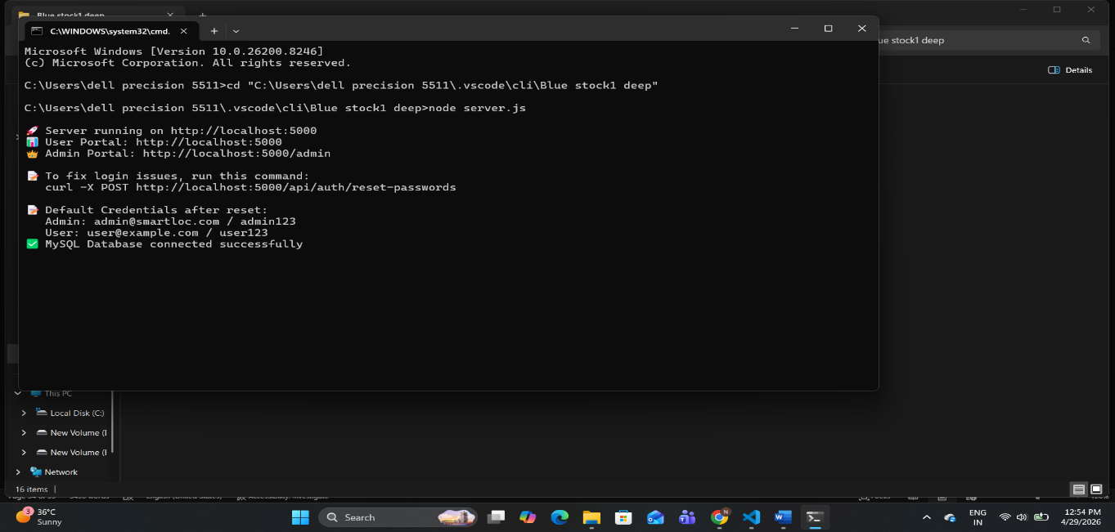Register: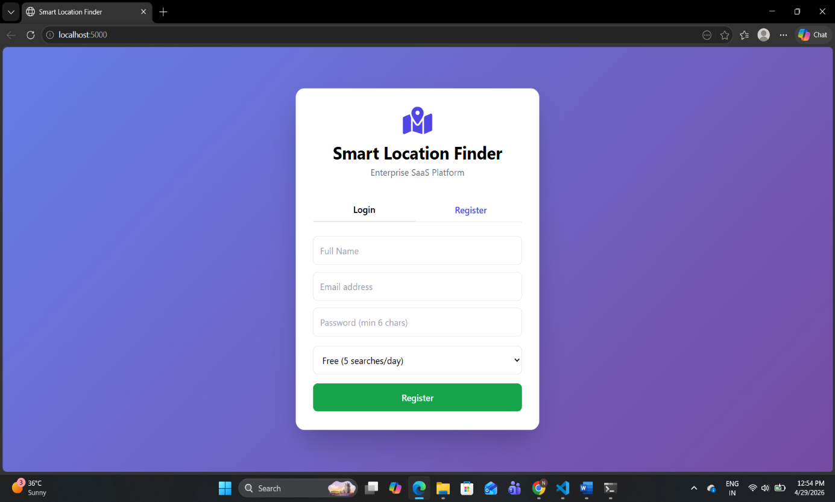lol
Login: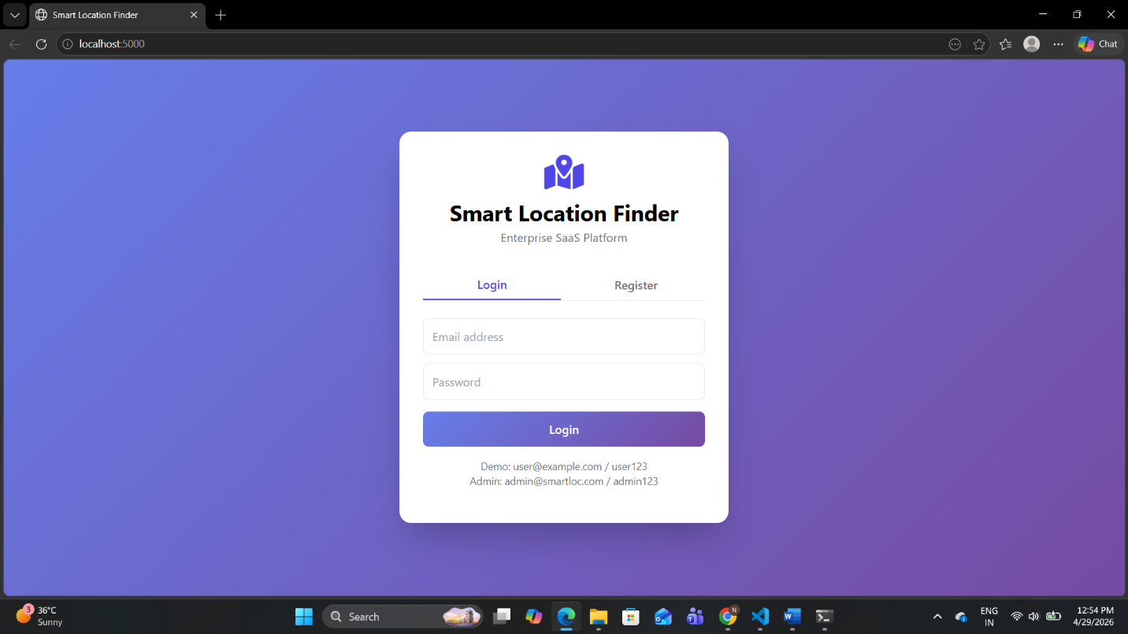user Dashboard: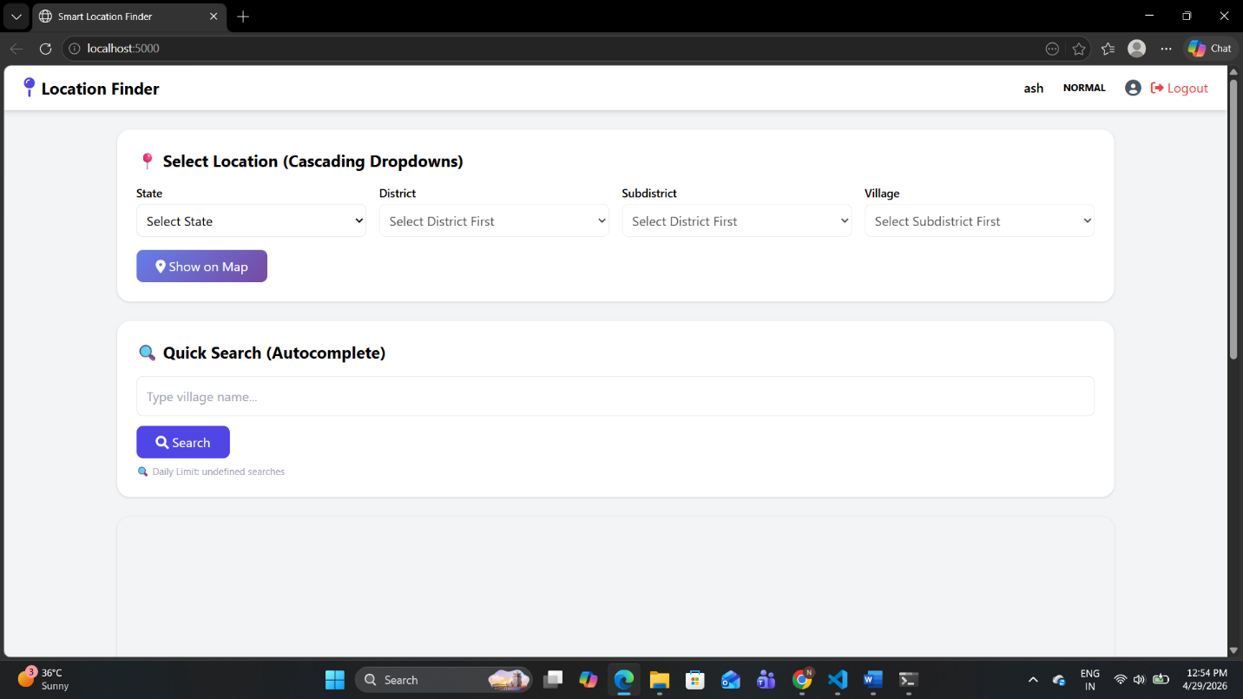s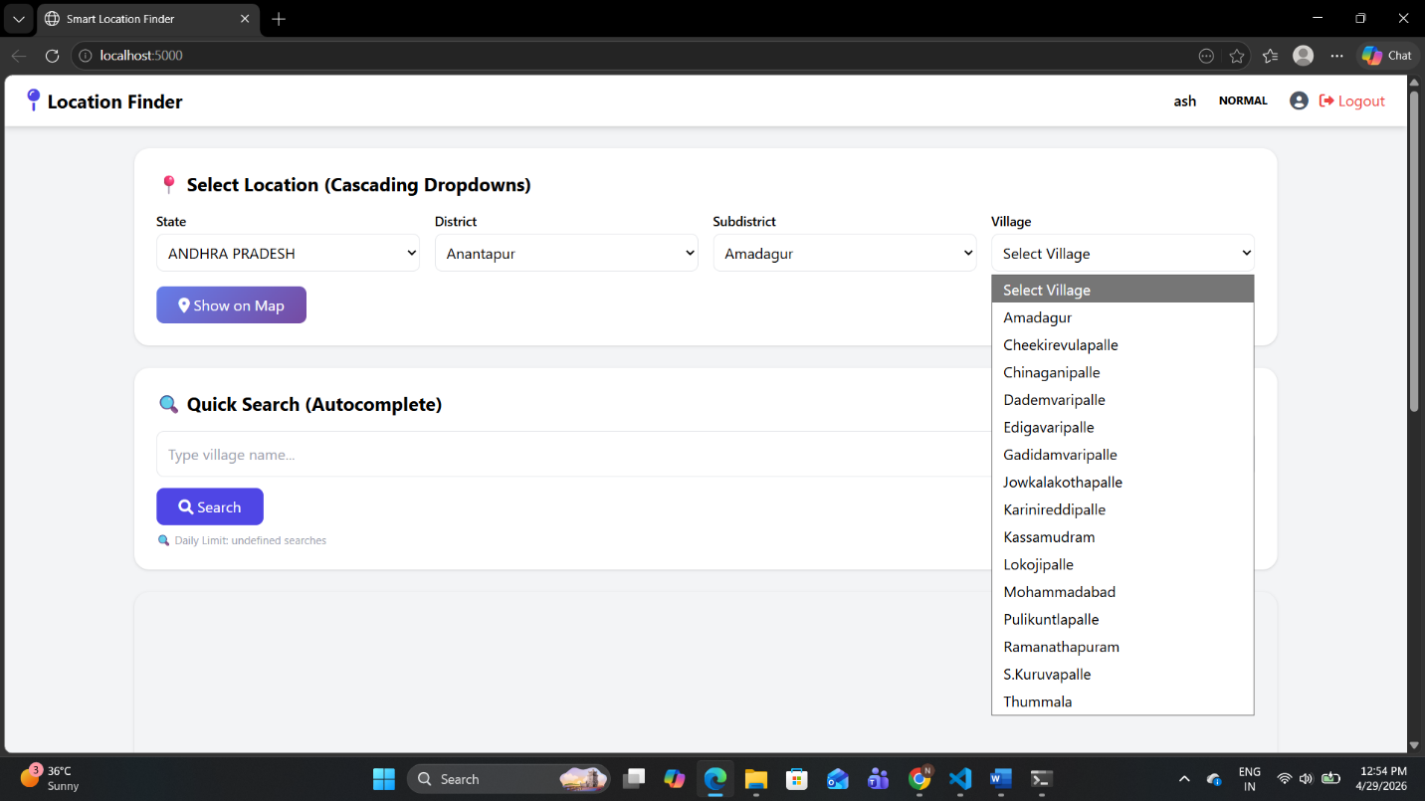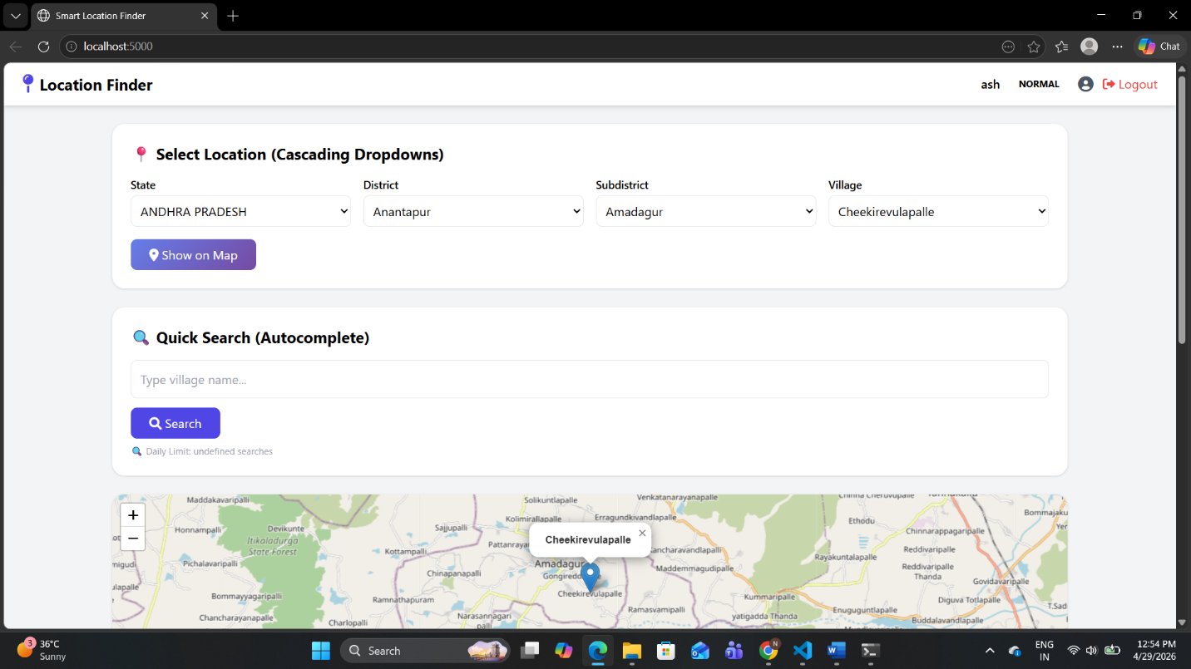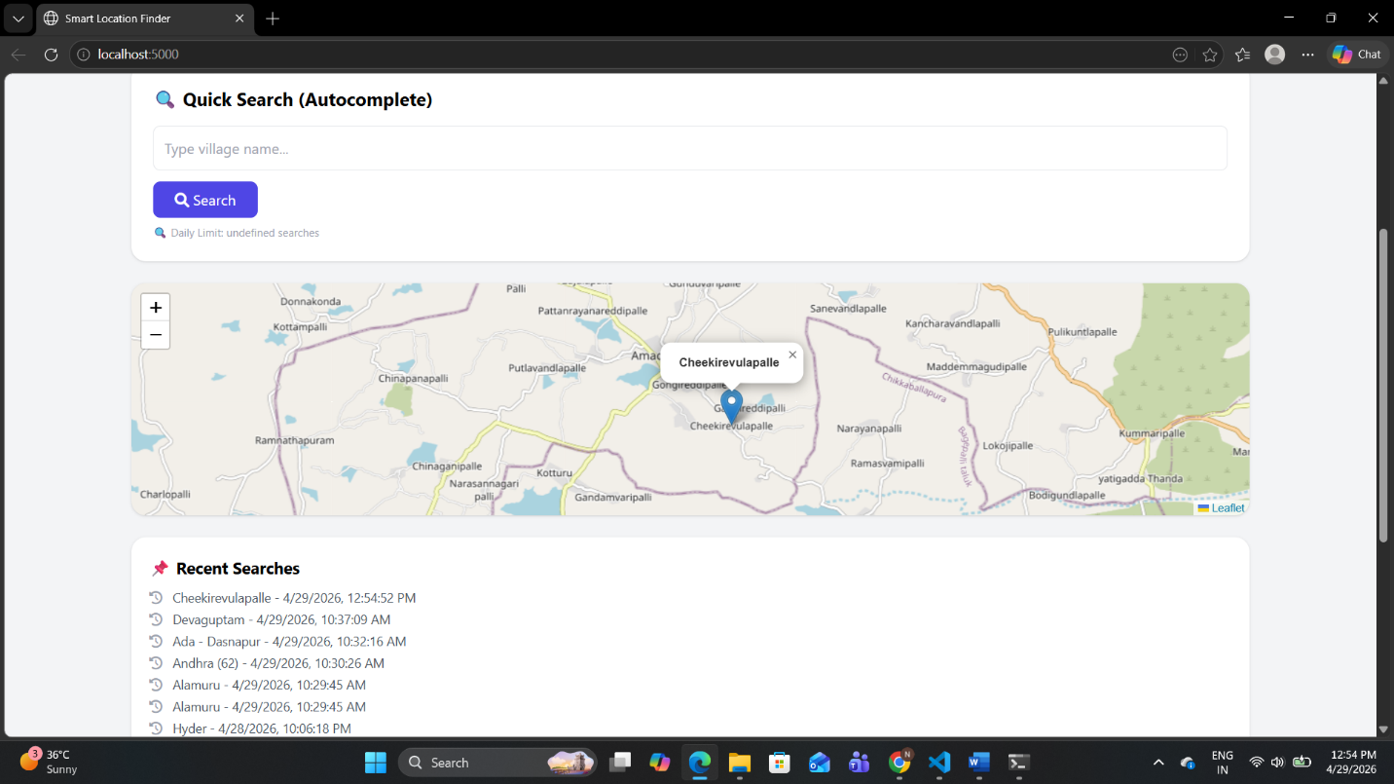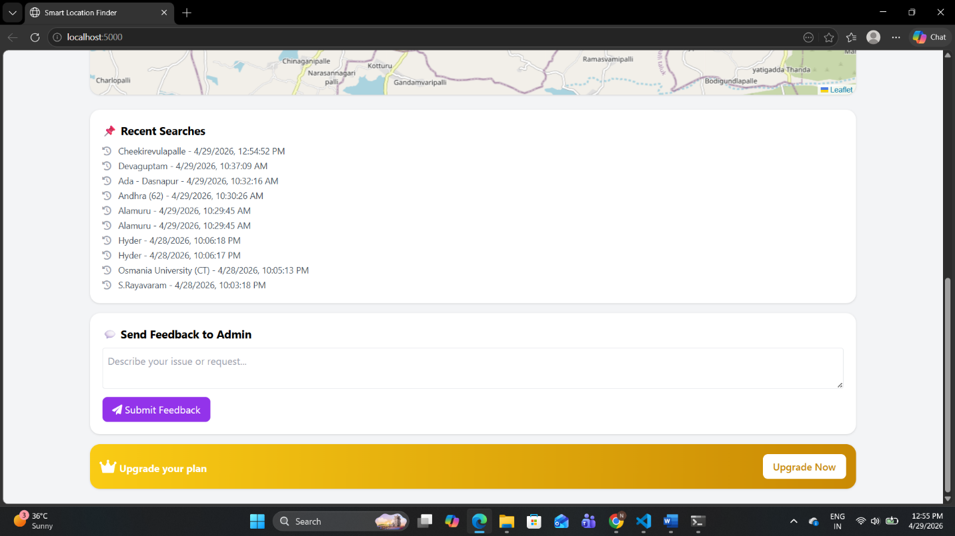

Admin login:
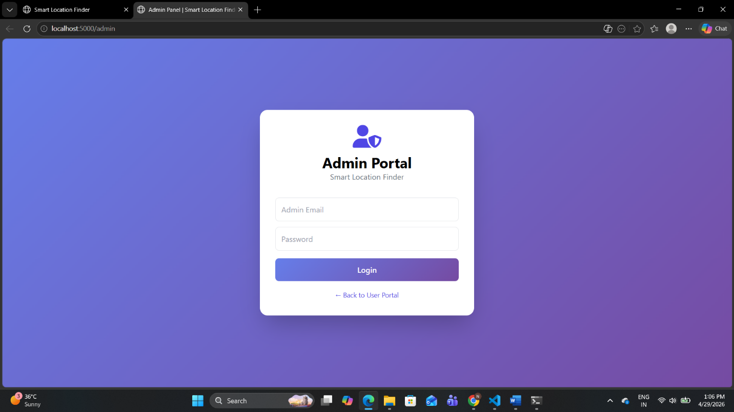Admin Dashboard: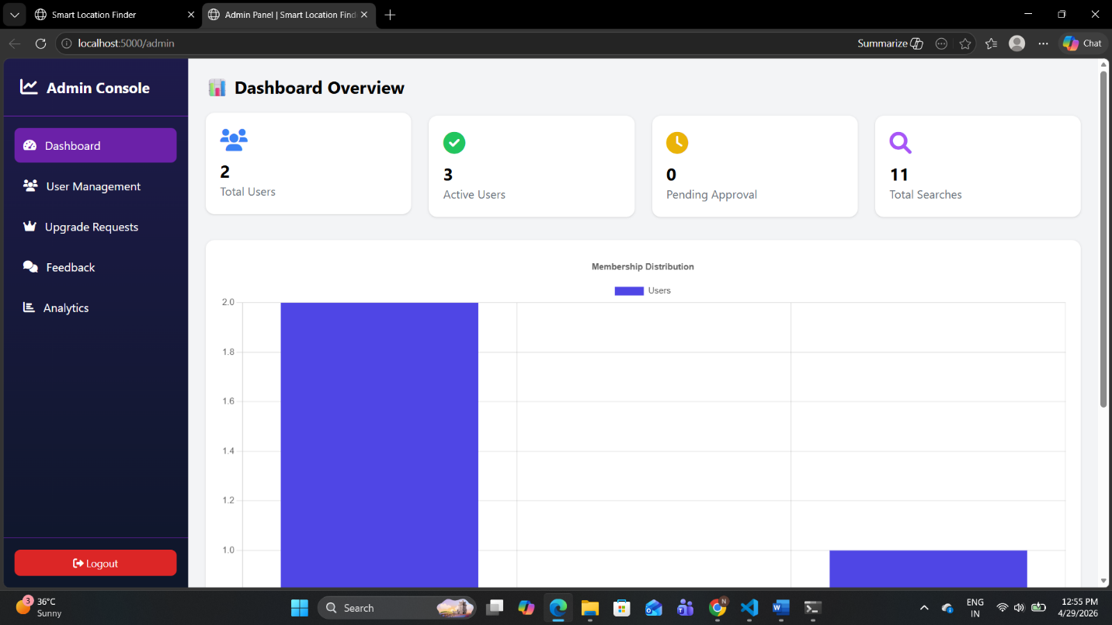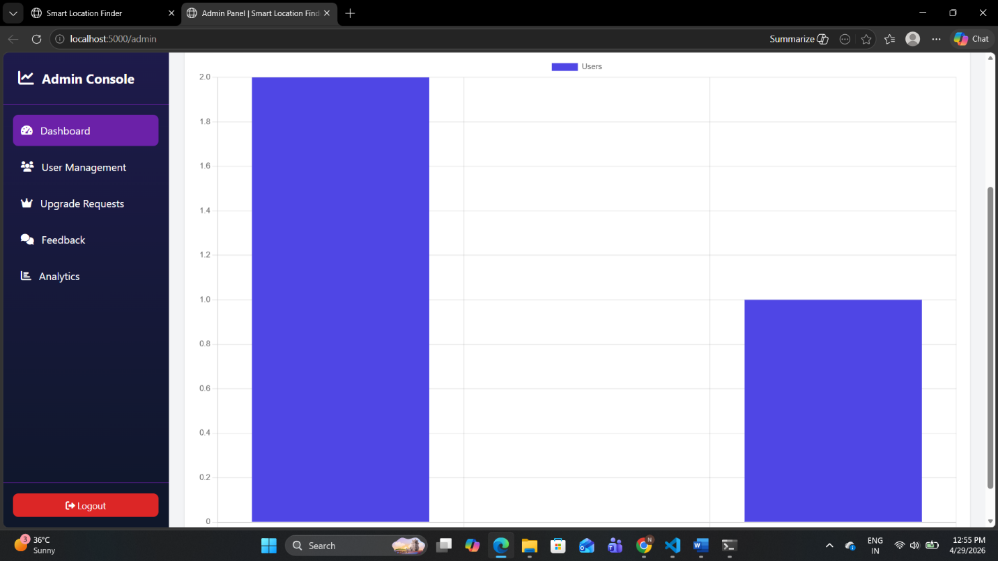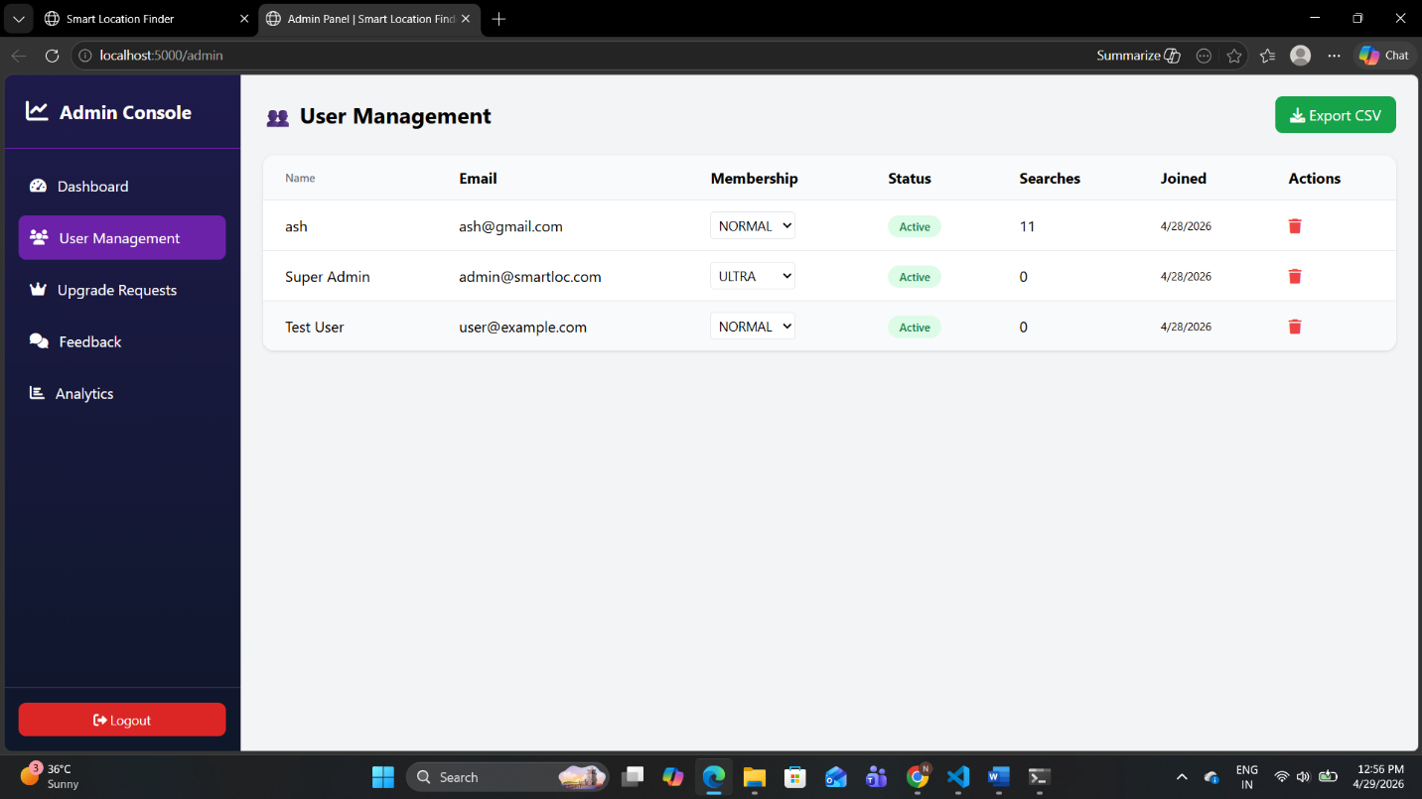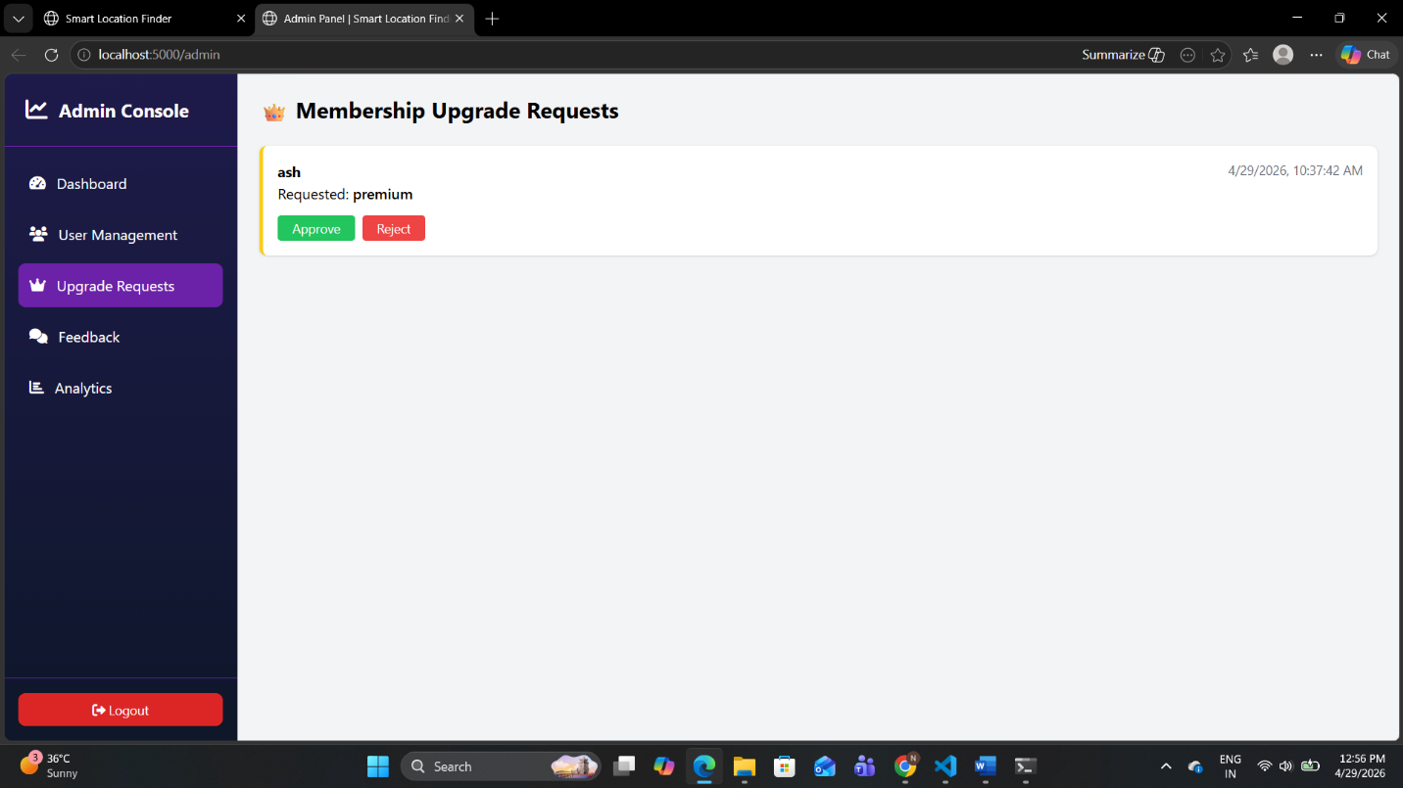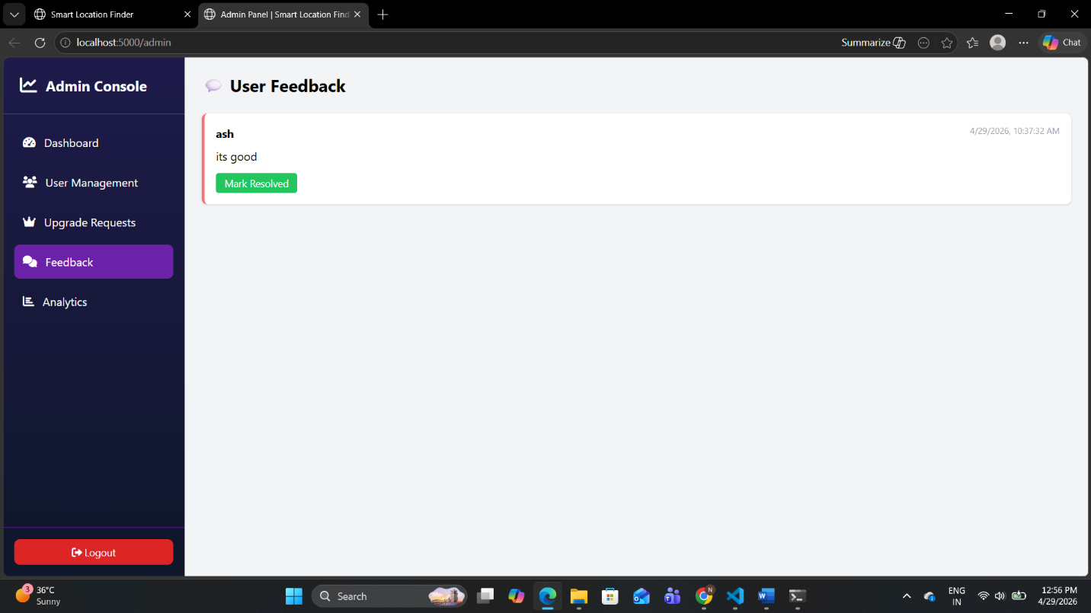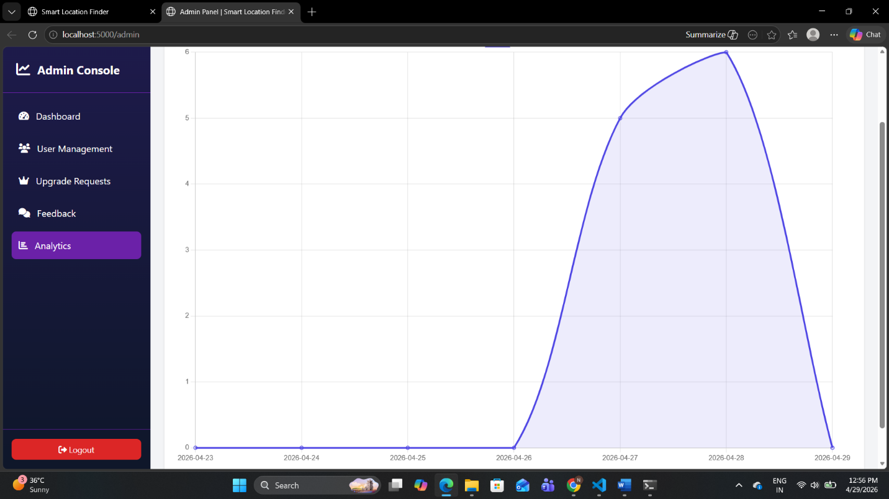

REFERENCES
ONLINE RESOURCES
No | Resource | URL
1 | Node.js | https://nodejs.org
2 | Express.js | https://expressjs.com
3 | MySQL | https://dev.mysql.com
4 | JWT | https://jwt.io
5 | bcrypt | https://npmjs.com/package/bcrypt
6 | Leaflet.js | https://leafletjs.com
7 | Tailwind CSS | https://tailwindcss.com
8 | Chart.js | https://chartjs.org
9 | OpenStreetMap | https://openstreetmap.org
10 | Font Awesome | https://fontawesome.com

